## **LoginActivity:**

## 

## 

## 

## **SignUpActivity:**

## 

## **DashboardActivity**

## **SearchActivity**

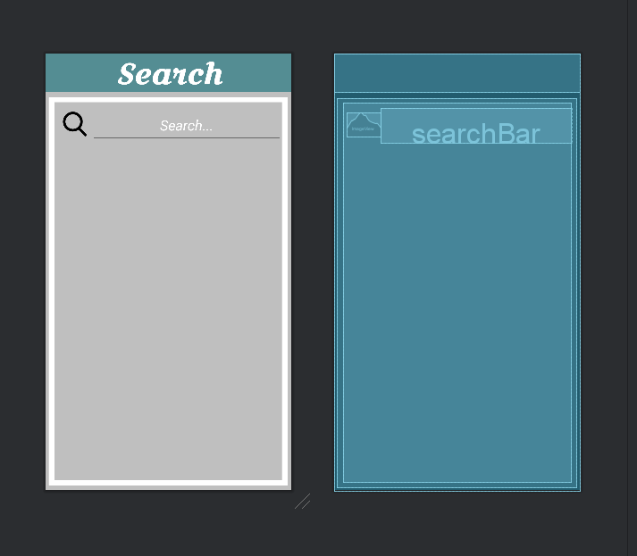

## **MarketplaceActivity**

## **ItemDetailsActivity**

## **DeliveryMethodActivity**

## **BuyConfirmationActivity**

## **AppointmentsActivity**

## **ApptConfirmationActivity**

## **SettingsActivity**

## **SCREENS RUNNING IN EMULATOR (WHATS APPLICABLE)**

